WEB TECHNOLOGY [CAT – 2 ] PROJECT

TITLE :ONLINE LIBRARY MANAGEMENT SYSTEM

TEAM NO: 13

TEAM MEMBERS :DHARANISH S AND SAVITHA O P

DESCRIPTION :An Online library management is a project that manages and stores books information electronically according to students needs. The system helps both students and library manager to keep a constant track of all the books available in the library. It allows both the admin and the student to search for the desired book. It becomes necessary for colleges to keep a continuous check on the books issued and returned and even calculate fine. This task if carried out manually will be tedious and includes chances of mistakes. These errors are avoided by allowing the system to keep track of information such as issue date, last date to return the book and even fine information and thus there is no need to keep manual track of this information which thereby avoids chances of mistakes.  
Thus this system reduces manual work to a great extent allows smooth flow of library activities by removing chances of errors in the details.

MODULES:

* **Admin login:** Admin is the one who administers the system by adding or removing e-books into and from the system respectively.
* **User login:** Students have to register themselves into the system to create an account. After registering successfully, they can then login into the system by entering 10 digit mobile number and their email id.
* **Add and Update Books:** The admin can add books to the system by entering the details of the books and can even update the details.
* **Search option:** Admin and Students can even search for books by entering the name of the book.
* **View Order-**The admin can view order for the books.
* **Place order-** The students can place order for the books and simultaneously the quantity of the book ordered will be decremented.
* **Calculate Fine-** The student can view the issue and expiry date for the book issued and can even calculate fine.

Advantages

* The system excludes the use of paper work by managing all the book information electronically.
* Admin can keep updating the system by providing the new books arrival in system and their availability thus students need not to go to library for issuing purpose.
* The system has books well organized and systematically arranged in different categories in the system so that user can easily search and find the book.
* Thus, it saves human efforts and resources.

Disadvantages

* There is no human interaction if users have some enquiry.
* Online systems require high-speed internet connectivity.
* The data stored is prone to cyber hacks.Opting for a reliable online system eliminates the risk.
* Complicated to operate , risk of computer virus.

COMPONENTS:

1. Computer system.

2. Networking system.

3. Software.

4. Database

5. Server and other tools to be used.

FUNCTIONALITIES:

HTML ,JAVASCRIPT,PHP CODE USING XAMPP SERVERAND OTHER RELATED FUNCTIONS needed to code the program.

SPECIFICATION OF PHP FILES:

* Login form
* Signup form

SOURCE CODE:

Login .php

<html>

<head>

<title>Login Form</title>

</head>

<body>

<font face="calibri" size="8"> Login Form</font>

<br />

<br /><form method="post" action="Login-row insert.php" >

<label for="users_email">Email</label>

&nbsp;&nbsp;&nbsp;&nbsp;&nbsp;&nbsp;&nbsp;&nbsp;

<input type="text" name="users_email" id="users_email" /><br /><br />

<label for="users_pass">Password</label>

&nbsp;&nbsp;&nbsp;

<input name="users_pass" type="password" id="users_pass" /><br /><br />

<input type="submit" value="Submit"/>

<input type="reset" value="Reset"/>

</form>

</body>

</html>

Signup:

<?php

// Connect to the database

$host="localhost";

$user="root";

$password="";

$connect=mysqli_connect($host,$user,$password,"my_signame");

if(mysqli_connect_errno($connect))

{

echo 'Failed to connect***';

}

else

{

echo 'Connection to db - Success...';

}

// Grab User submitted information

$firstname = $_POST["sig_firstname"];

$lastname = $_POST["sig_lastname"];

$email = $_POST["sig_email"];

$pass = $_POST["sig_pass"];

$passc = $_POST["sig_passc"];

$phn = $_POST["sig_phn"];

print("<br>");

print("<br>");

echo 'your firstname is';

print( "$firstname" );

print("<br>")

echo 'your lastname is';

print( "$lastname" );

print("<br>")

echo 'Your Mail-id is ';

print( "$email" );

print("<br>");

echo 'Your Password is ';

echo "$pass";

print("<br>");

echo 'Your Password is ';

echo "$passc";

print("<br>");

echo 'phone number is';

print( "phonenumber" );

print("<br>");

$result = mysqli_query($connect,"SELECTsig_firstname, sig_lastname, sig_email, sign_pass, sign_passc, sig_phn FROM sig");

print("<br>");

$flag = 0;

while($row = mysqli_fetch_row($result))

{

if($firstname==$row[0] && $lastname==$row[1] && $email==$row[2] && $pass==$row[3] && $pass==$row[4] && $phonenumber==$row[5])

{

$flag = 5;

break;

}

}

print("<br>");

if ($flag==4)

echo "You are a validated user.";

else

echo "Sorry, your credentials are not valid, Please try again.";

?>

SCREENSHOTS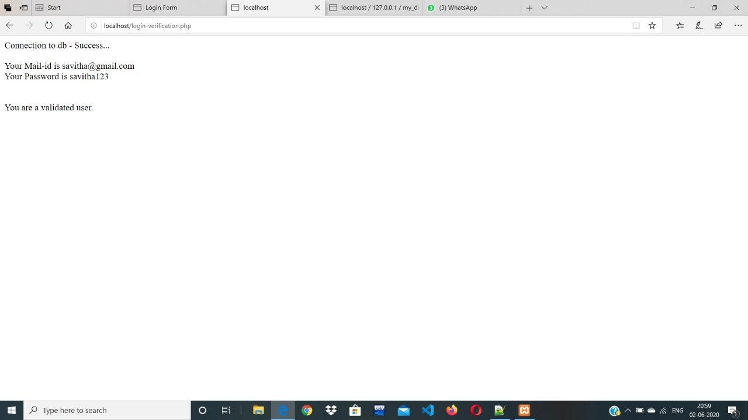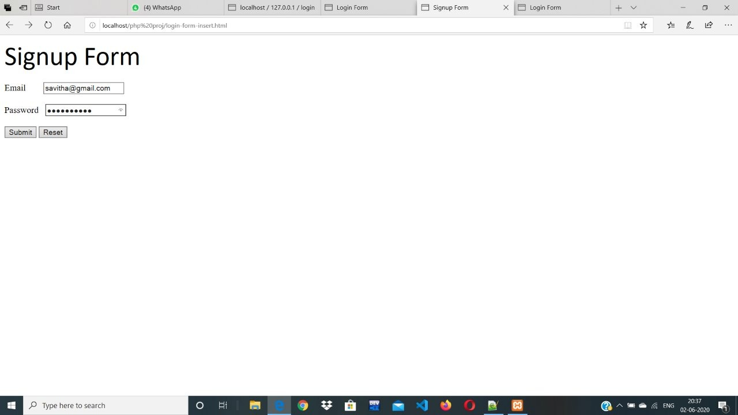

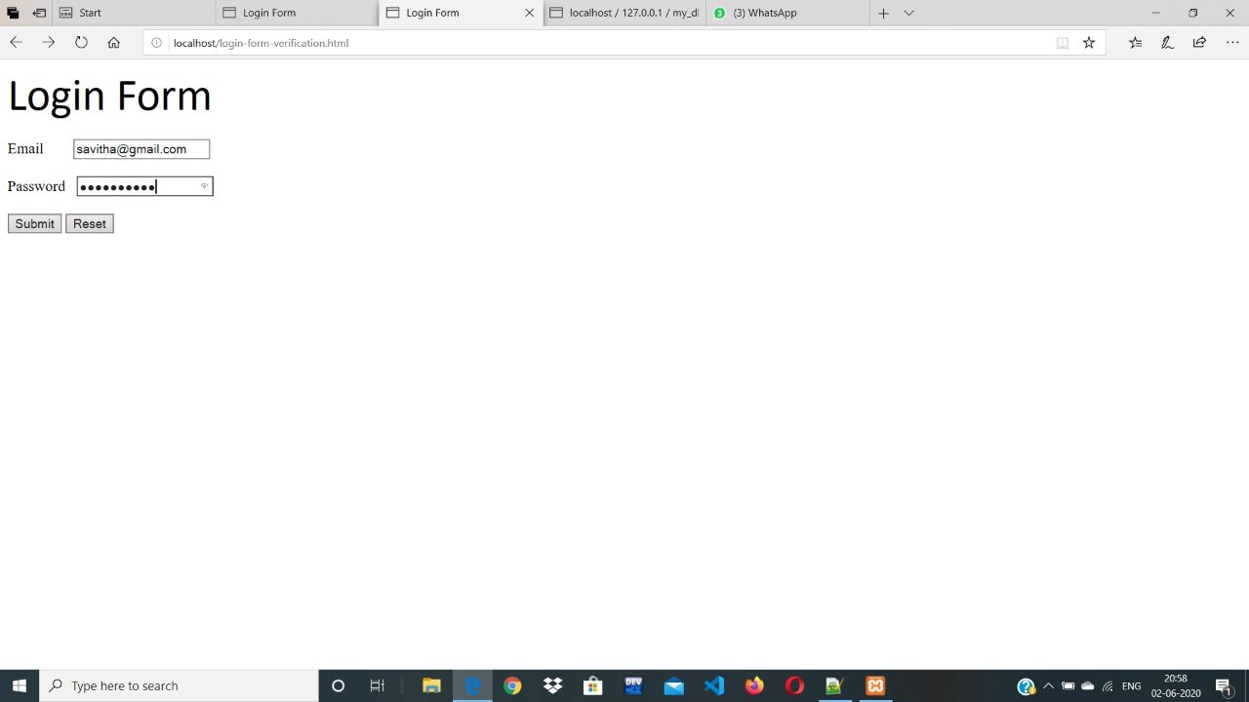

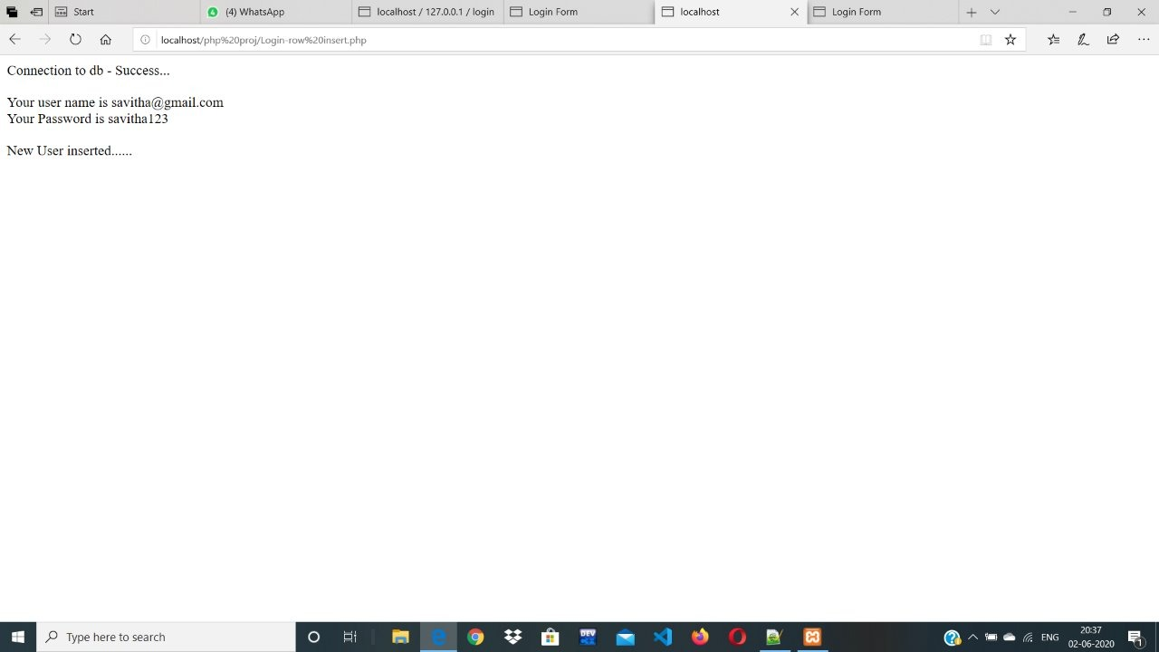

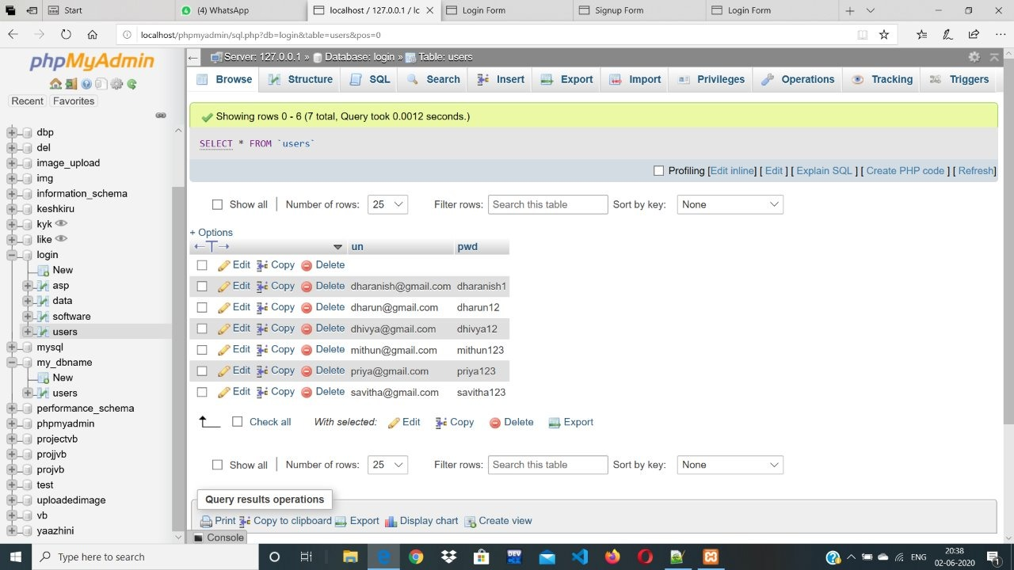

CREATION OF DATABASE:

Library

CREATION OF TABLE:

* Login
* Student
* Books
* Comments

When Php code to execute in a proper ways .it requires

1. Model->connection for database
2. View->list
3. Controller->action

OUTPUTS:

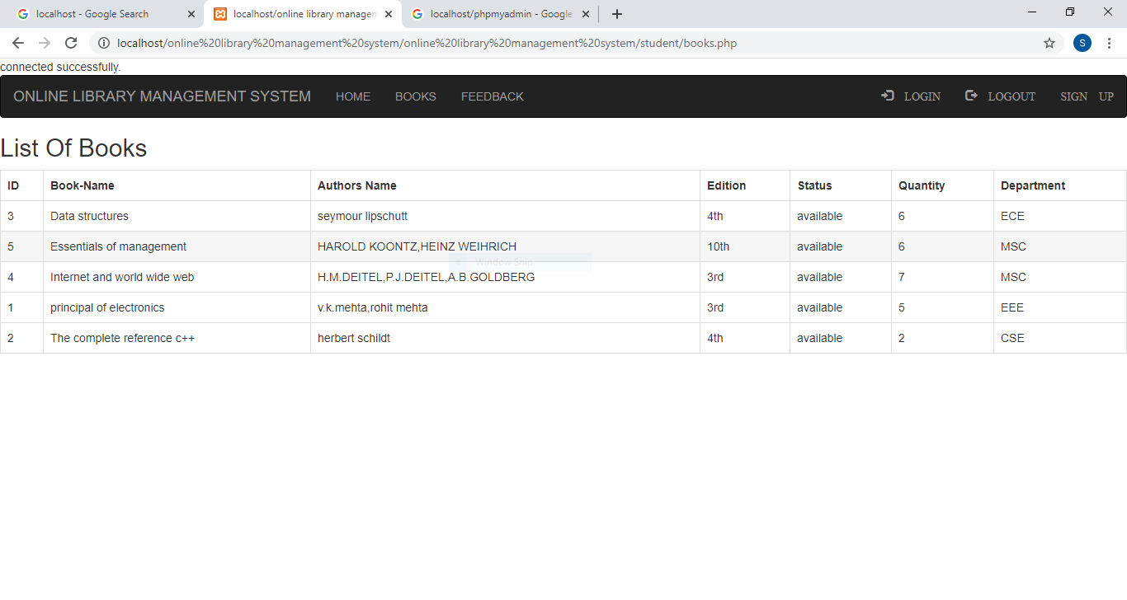

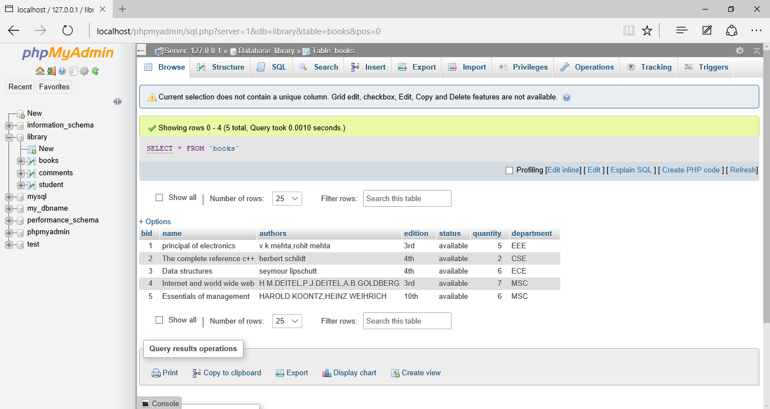

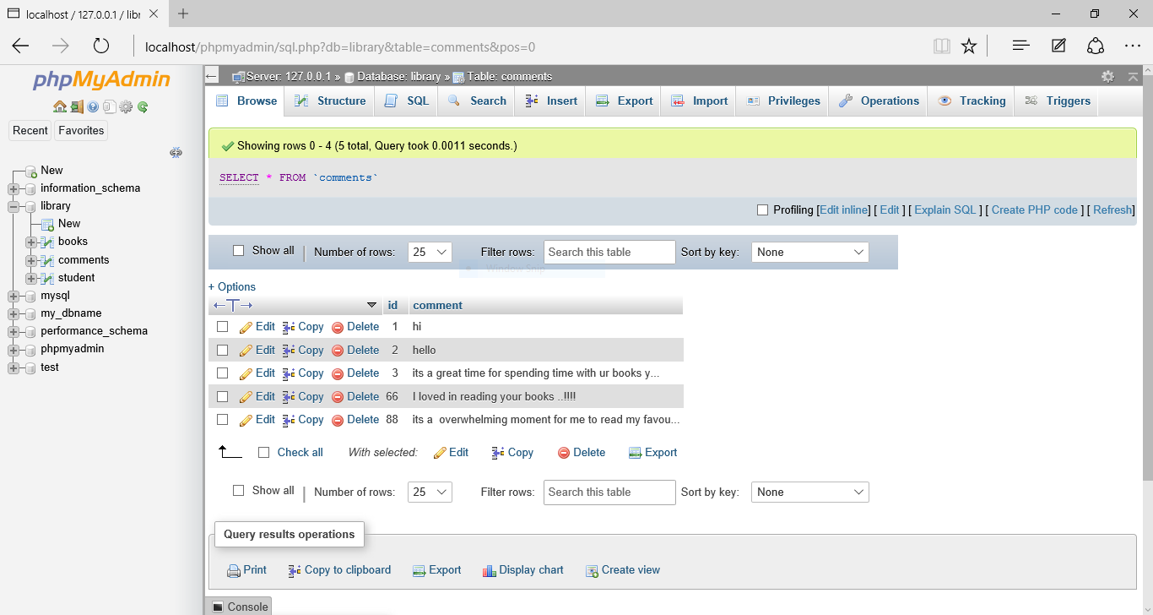

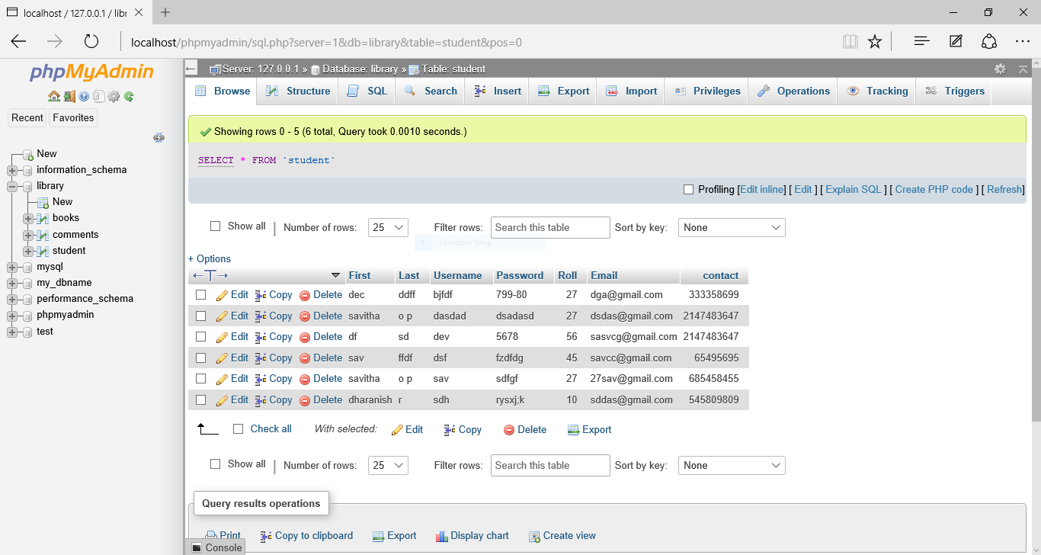

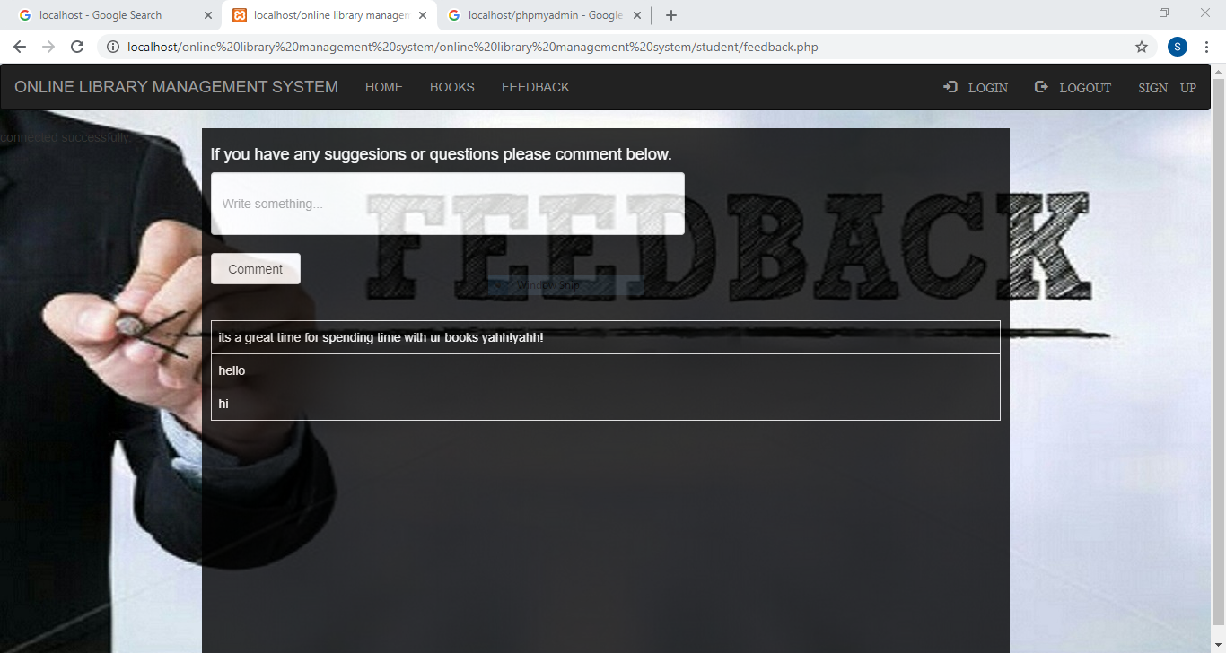





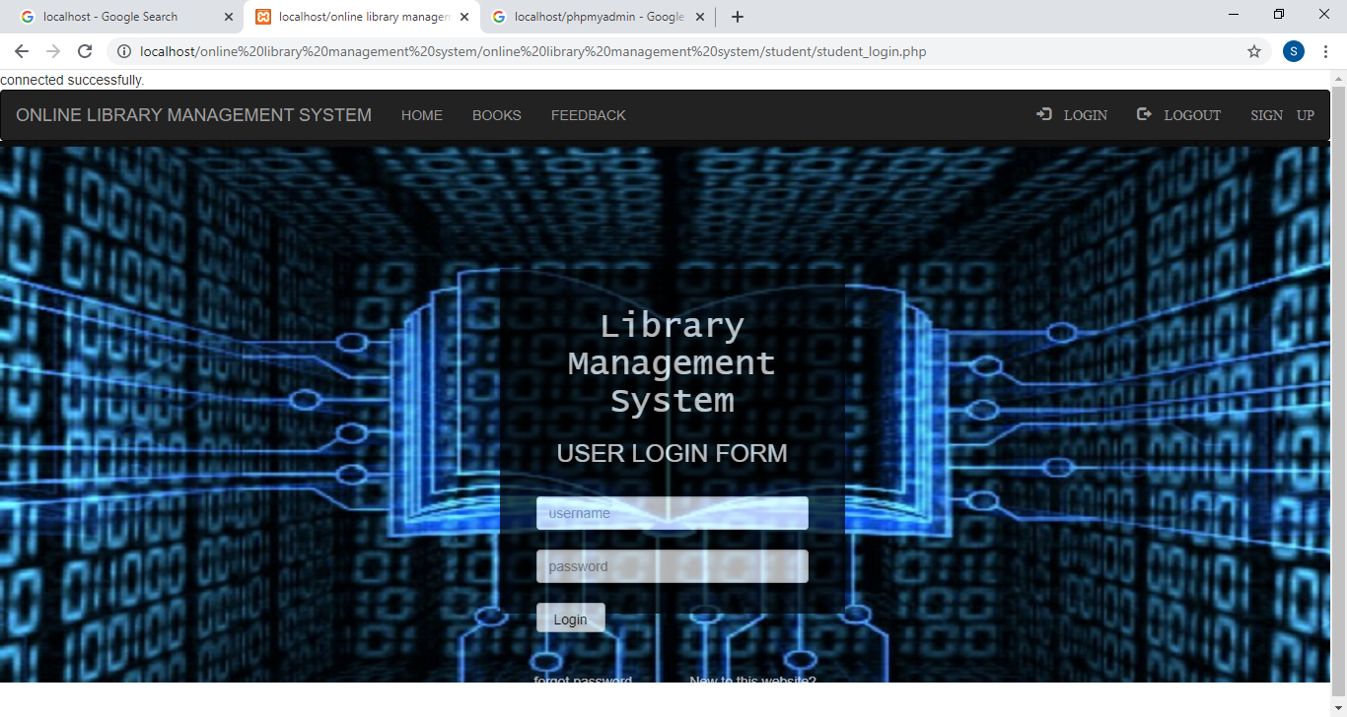

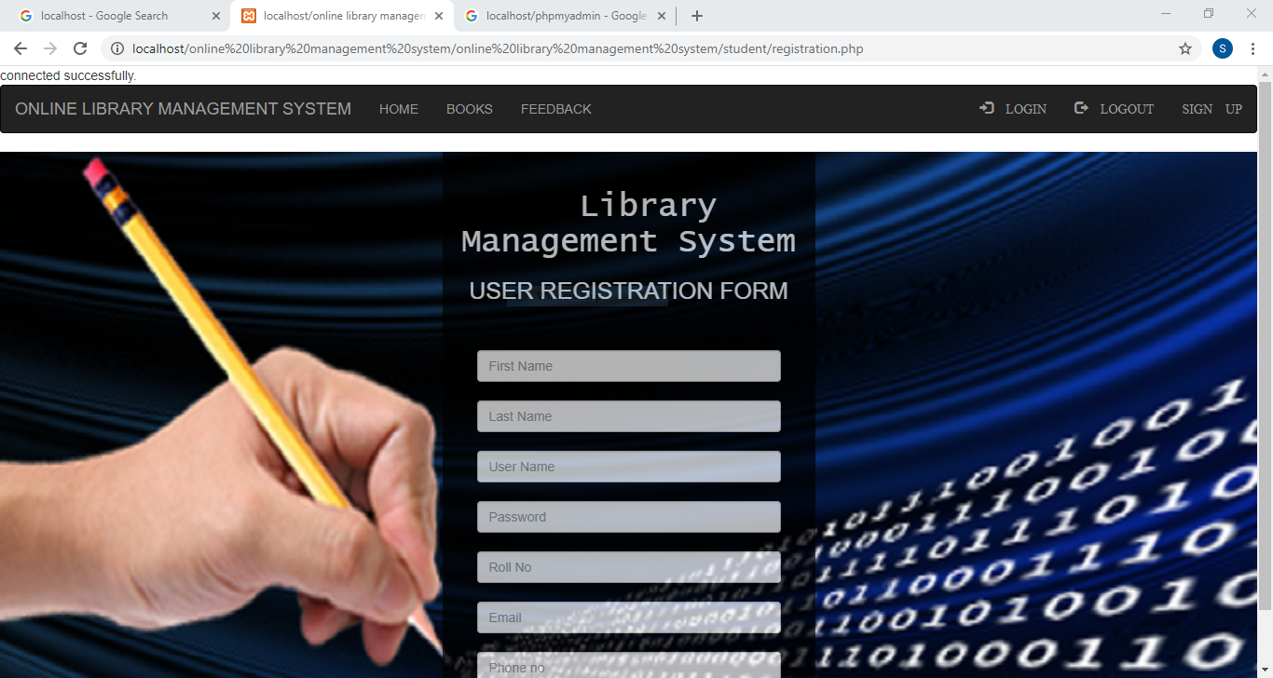

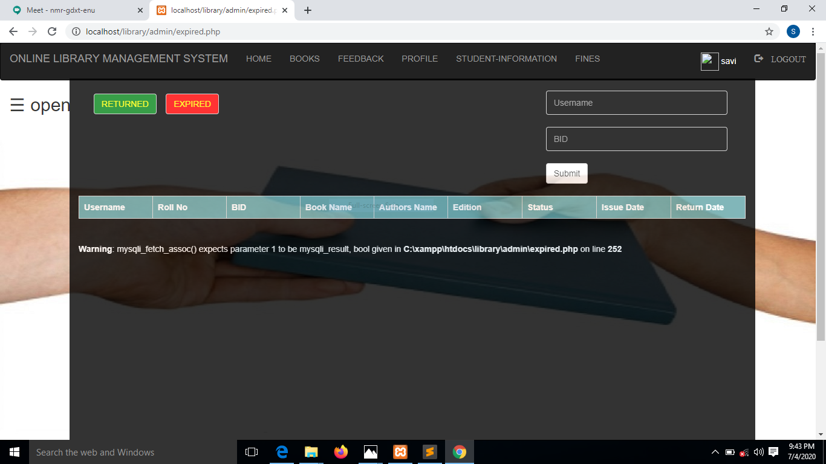

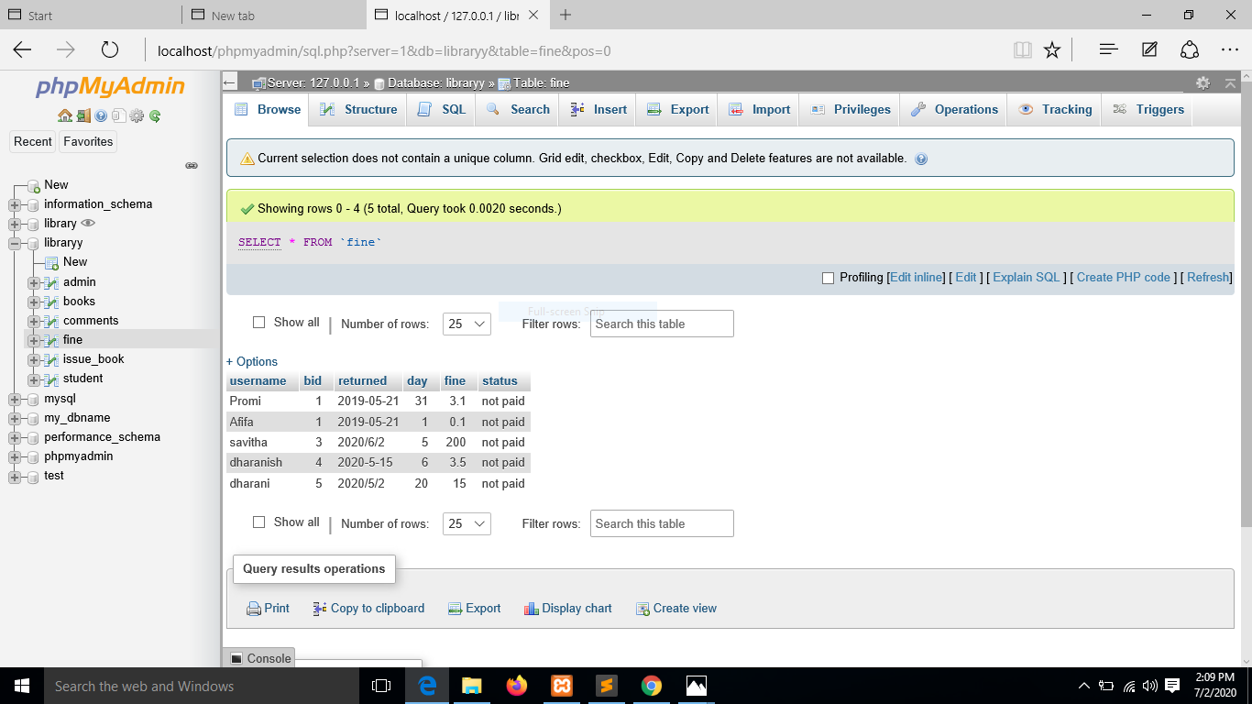

MESSAGE SYSTEM:

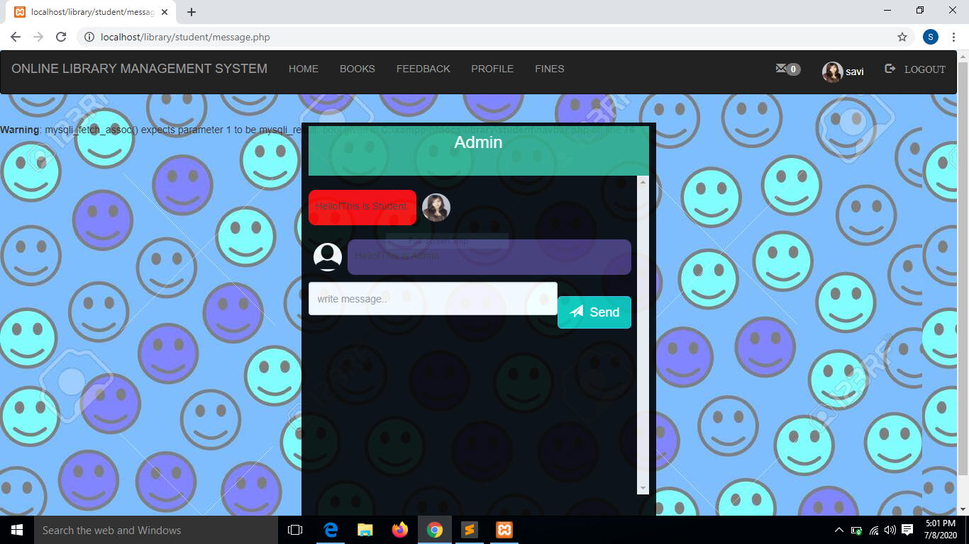

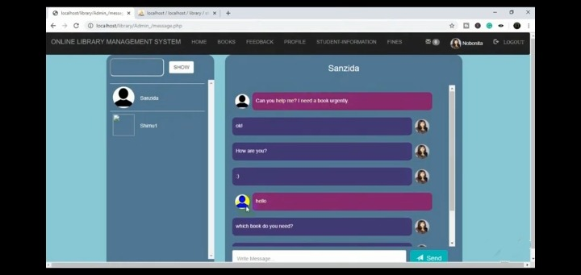

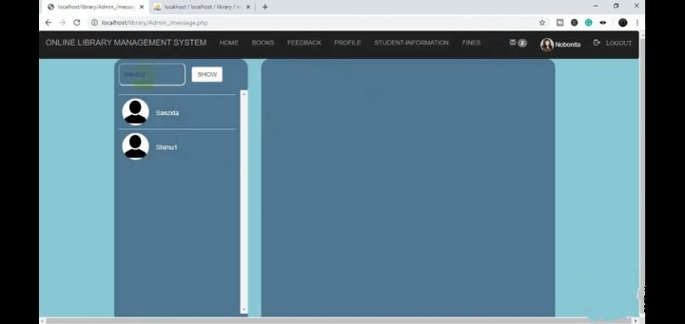

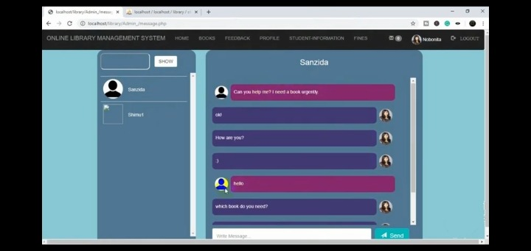

Presented by

Savitha O P

Dharanish S

------------------****************-----------------

Thank you